NAME: | Georelle Ila, Joshua Sarcol | DATE: | 11/19/2023

PRACTICE EXERCISE # 7.1

LE 7_11 Largest and Smallest
Design the logic for a program that allows a user to enter 10 numbers, then displays all of the numbers, the largest number, and the smallest.

Pseudocode: LE 7_11 Largest and Smallest
main()
START
- INITIALIZE list as array of integers
- FOR i = 0 to 10 exclusive by 1
  - PROMPT and GET list[i]
- ENDFOR
- CALL module, largest = largestInList(list)
- CALL module, smallest = smallestInList(list)
- FOR i = 0 to 10 exclusive by 1
  - PRINT list[i]
- ENDFOR
- PRINT largest and smallest
STOP

largestInList(arr[])
- INITIALIZE result as arr[0]
- FOR i = 1 to 10 exclusive by 1
  - IF result < arr[i]
    - SET result as arr[i]
  - ENDIF
- ENDFOR
RETURN result

smallestInList(arr[])
- INITIALIZE result as arr[0]
- FOR i = 1 to 10 exclusive by 1
  - IF result > arr[i]
    - SET result as arr[i]
  - ENDIF
- ENDFOR
RETURN result

Flowchart: LE 7_11 Largest and Smallest
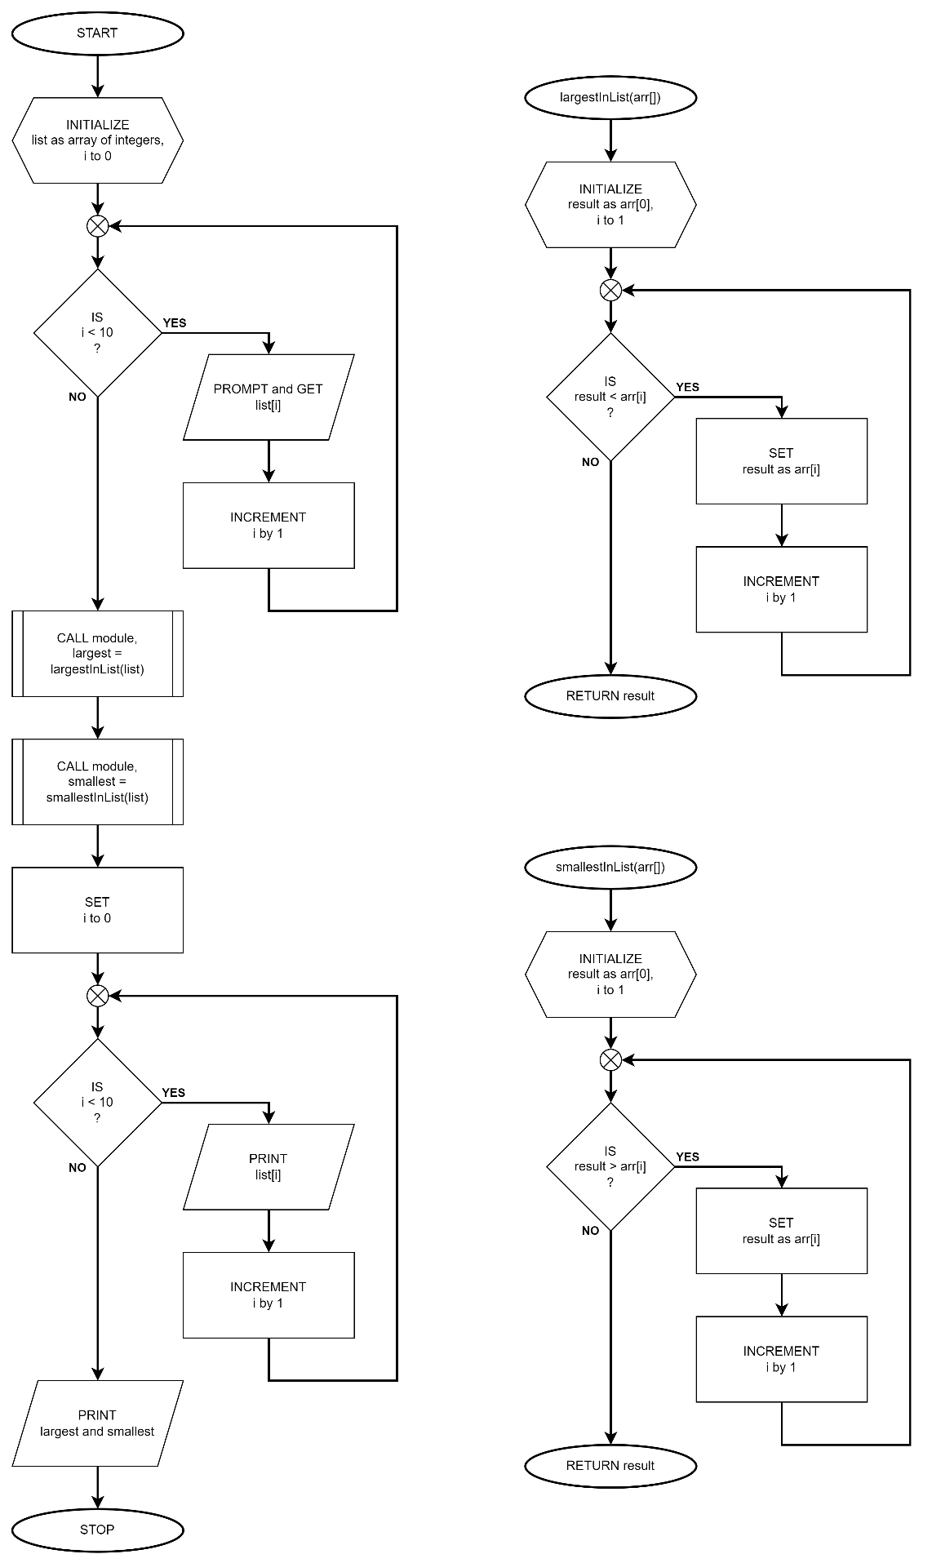

LE 7_12 Vowels and Consonants in String
Ask a string and determine how many vowels and consonants.

Psuedocode: Vowels and Consonants in String
main()
START
- INITIALIZE word as array of characters
- PROMPT and GET word
- CALL module, vowels = vowelCount(word)
- CALL module, consonants = consonantCount(word)
- PRINT vowels and consonants
STOP

vowelCount(arr[])
START
- INITIALIZE result to 0
- FOR i = 0 to length of arr exclusive by 1
  - IF arr[i] is a letter and a vowel
    - INCREMENT result by 1
  - ENDIF
- ENDFOR
RETURN result

consonantCount(arr[])
START
- INITIALIZE result to 0
- FOR i = 0 to length of arr exclusive by 1
  - IF arr[i] is a letter and not a vowel
    - INCREMENT result by 1
  - ENDIF
- ENDFOR
RETURN result

Flowchart: Vowels and Consonants in String
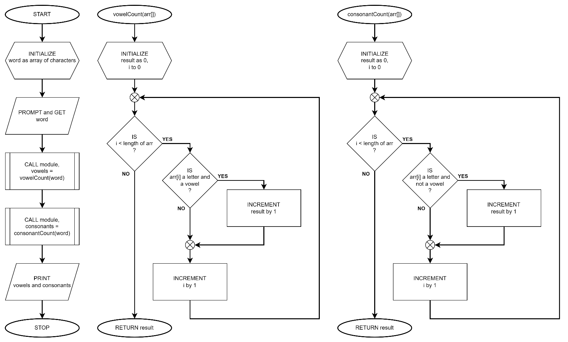

LE 7_13 Longest String
Ask for 5 strings and display the longest string.

Psuedocode: LE 7_13 Longest String
main()
START
- INITIALIZE words as two-dimensional array of characters of size [5][100]
- FOR i = 0 to 5 exclusive by 1
  - PROMPT and GET words[i]
- ENDFOR
- CALL module, longestWord = words[longestString(words)]
- PRINT longestWord
STOP

longestString(arr[][])
START
- INITIALIZE length as length of arr[0] and result as 0
- FOR i = 1 to 5 exclusive by 1
  - IF length < length of arr[i]
    - SET length as length of arr[i]
    - SET result as i
  - ENDIF
- ENDFOR
RETURN result

Flowchart: LE 7_13 Longest String
